Link Dots Pro
How to install. 2
How to play 3
Reskin 4
Basic Game Settings 5
Setup your own bundle ID 5
Other game information 5
Advanced Scripts 6
Important API and functions 8
About Level Data 9
Define colors 11
Scores 12
Use as in-game puzzle 13
Localization 14
Ready your localization file 14
Add new language to system 14
Use localization in game 16
Advertisement 17
Exporting to IOS 18
Publish to appstore 19
How to get support 20

How to install.
Make sure the inspector panel include tags and layers which default project not have. Which means you have set up the project properly.
To test the game, search startscene by project panel of unity editor to found the scene file named startscene.
You can also found the scene files under
Assets/linkdot/gamelevel
Double click on it to active the scene. Then you can run the game correctly. Other scene files can running independently but you may not get correct level data for test without a correct initialization sequence.

How to play
This was a classic game which you may already played in many places. The game rule were very clear even without a tutorial. Just touch and hold on a dot then move and drag without release your finger or mouse button. You may draw a line of the dot’s color. Try to connect all the dots with the same color but avoid crossing linkages. While you have successfully connected all the lines. The win panel would pop up automatically.

Reskin
The only thing you need to know about reskin is the unity sprite or the unity ui image. Find the referring picture sources by just click on the image/spirte component on each gameobject from editor window.
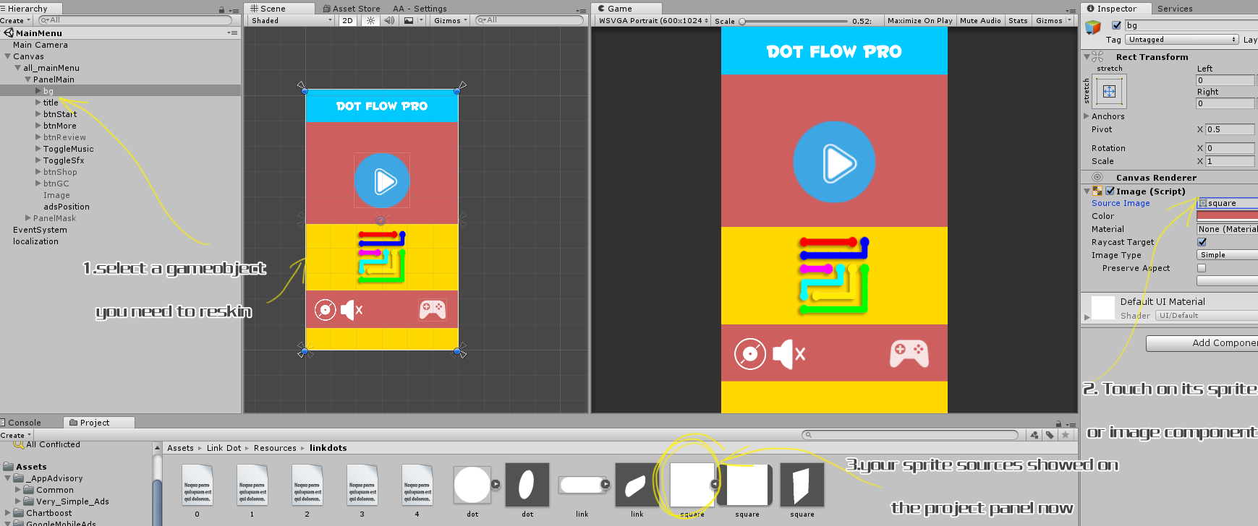
(zoom the picture by holding ctrl+mouse wheel)
All other resources were under
Assets/Link Dot/Resources

Basic Game Settings

Setup your own bundle ID
Each game must have a different Bundle id. So you must made the id to fit the id you request from apple or gp.
File->build setting, open the build setting panel. Find and click player setting button.
On right inspector panel, touch other settings panels. Change buddle id in bundle identifier section.

Other game information
Type const.cs to search on project panel.
Pay attention for LEADER_BOARD_ID,appid.
These 2 relative your gamecenter id and your game app id.

Search and found
Application.OpenURL ("http://itunes.apple.com/WebObjects/MZSearch.woa/wa/search?submit=seeAllLockups&media=software&entity=software&term=
Change the url you need to be a more games link.

Advanced Scripts
Under Assets->link Dot->scripts folder. There are all scripts of the game. The major files’ detail were listed as below.
Const.cs: some parameters not for game but for your publish services like user id etc.
GameData.cs: Store the temporary variables of the game like score, level, time cost, etc. Can be called by Game.getInstance().xxx in any place of the game.
GameManager.cs: The most important file for initialize and process game controller service like music, advertisement, iap etc. Can be called by GameManager.getInstance().xxx in any place of the game.
LevelMenu: The level menu UI file. Attached on the UI root element of the levelmenu scene.
MainScript.cs: the game logical class. Attached on the gameobject of the game level scene. Process the game start ,retry,or the win or fail.
PanelMain.cs: Attached on the UI element of MainMenu (game title) Scene. Just deal with the things for game start, rate etc.
StartSplash.cs：File attached on the gameObject of startScene ,The start scene of the game. It initialize some forever exist object.
TipPanel.cs: process the UI events of the tip panel.Not used for this game yet.
Winpanel.cs:process the UI events of the game win panel.

Important API and functions
Now all the functions and variables were commented in the script files and you can open each script to see. There is not much to say as most of them only describes the UI which all can be understand easily for a glance.

To play a music: Use GameManager.getInstance().playMusic(xxx);
To play a sound effect: Use
GameManager.getInstance().playSfx(xxx)
Remember to put your music and sound effect file into assets/link dot/Resources/sound source folder. And for a background music you must start its name with text bg ,Like bg1,bg2,bgmusic.

About Level Data
Levels were described as Json files.
See under Asserts/Resources/linkdots
There are 0.txt – 4.txt 5 txt files.
These are levels datas refer from easy to expert
Now open 0.txt as an example. We see the first line
{r:5,c:5,l:[{v:[{x:1,y:1},{x:2,y:1},{x:3,y:1},{x:3,y:2},{x:3,y:3},{x:2,y:3}]},{v:[{x:1,y:3},{x:1,y:4},{x:2,y:4},{x:3,y:4}]},{v:[{y:1},{},{x:1},{x:2},{x:3},{x:4}]},{v:[{y:4},{y:3},{y:2},{x:1,y:2},{x:2,y:2}]},{v:[{x:4,y:4},{x:4,y:3},{x:4,y:2},{x:4,y:1}]}]}
This looks very complex but actually very easy to understand. The Json file is like an array with grouped tags and which can be used to describes more attributes than pure arrays. But this example we only record coordinates and grid numbers’ information.
For this game, each line refers to one level. So the first line of 0.txt is the level1 data of the easy levels.
First we see the part described as {r:5,c:5
This means this level got 5 row and 5 columns.
Then we see very long data after the a l: tag
These would describe the level information of dots and lines.
In this part, we could find some v: tags separated it into several parts. We got 5 v tags which means this level includes 5 lines.
Yes, If you have tried to play the game. Now you should know, each line describes the coordinates of one color.
But we only requires the dots information right? We make a level by add all the dots and then let the player to work with the linkage.
So the first and the last coordinates in each v: tag were exactly the places where a pair of color dot should be. Dots were in pairs with same color because the game purpose is to link all the dots with uncrossing lines.
For example ,the first line [{x:1,y:1},{x:2,y:1},{x:3,y:1},{x:3,y:2},{x:3,y:3},{x:2,y:3}]
The (1,1) and (2,3) should be a pair of dots which showed on a level starts.
Why we not only gives the dots position but give the line paths. Because this information can be used for tips. You can use them yourself.
Another important things may mention is that sometimes you would find a coordinate just blank like {}
This means a the position of (0,0)

Define colors
Find GameData.cs
colors = new Color[] { Color.clear, Color.red, Color.blue, Color.magenta, Color.cyan, Color.green, Color.yellow, Color.gray, Color.white, Color.black, new Color(252f / 255f, 157f / 255f, 154f / 255f), new Color(249f / 255f, 205f / 255f, 173f / 255f), new Color(200f / 255f, 200f / 255f, 169f / 255f) };

This level data not include a detailed color, so you assign the color of each dot freely by yourself.
Remember you must leave the first color to color.clear as it was system used for the game.
And you must add colors to make sure that was enough for each level.
The Dots and lines resources were all included inside
Assets/Link Dot/Resources/linkdots
You could overwrite the picture and need not take care of the size. But the origin color must be white as it will be colorfied by the game.

Scores
The game count the totalscore at starts.
Refresh scores when finish each level. Temporary, each level you finishes ,you will get 1 score.
Score is not used for this game yet, to get the score information, call the API at any places you want.
GameData.instance.bestScore

Use as in-game puzzle
Find the level file named 3dTest
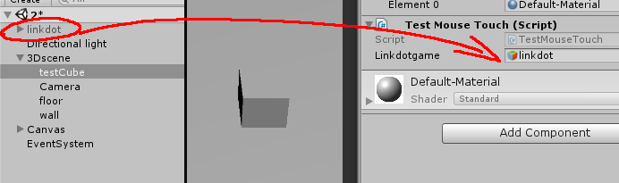
This is a simple test of how to play the game in a 3d scene. You see we assigned the linkdoor instance to be attached on the component of the cube. We click the cube ,Then we can play the game now.
Open TestMouseTouch.cs ,We see,
GameData.difficulty = 0;//0-4
GameData.getInstance().cLevel = 0;//0-49;
These 2 defines the level difficulty and which level you want to play.
The init() function should start the game then.
And the linkDotWin() function would process what to do when you win a level.
The game prefab used for the minigame is under
Assets/linkdot/src/prefab

Localization

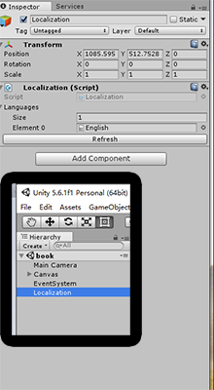
Ready your localization file
Find src/localization folder. Duplicate English.txt and rename it a new name like French.
Open the file, see like
btnBack = back
This means the btnBack key refers to the value of translation “back”
After your localization file were all ready, set the size of localization attribution to 2 or more and assign your language files.(see right picture)

Add new language to system
In GameData.cs,we see the function GetSystemLanguage().
This function get system language by switch branches.
You should add the language cases only when your localization file(txt) is ready. Otherwise if the system can not find the right translation file or the file does not include current translation phases, it would throw errors and break the game.

For default testing ,it is
public int GetSystemLaguage(){
int returnValue = 0;
switch (Application.systemLanguage) {
case SystemLanguage.Chinese:
returnValue = 1;
break;
case SystemLanguage.ChineseSimplified:
returnValue = 1;
break;
case SystemLanguage.ChineseTraditional:
returnValue = 1;
break;
default:
returnValue = 0;
break;
}
returnValue = 0;//test
return returnValue;
}
see returnValue = 0;//test
This line is uncommented. The language will always be English .If you may not have time to deal with your own native translation or you did not want a localization function for your game, just leave it uncommented. Otherwise, you should comment this line and make the system to decide which localization to choose.
The returnValue must be refer to the element order of localization Gameobject as I said upon.

Use localization in game
Just call like:
xxx.text = Localization.Instance.GetString("phasename");

Advertisement(deprecated)
Tools->app advervisory->settings To set up your ads ids.
The game requires native sdk.I already imported the chartboost and admob sdk.If you require the facebook or adcolony for your game. Just click the button on setting panel and down the referring sdks.

For detail. Please read online document .And don’t fogot to buy this plugin if you want to publish the game in any store.

IMPORTANT: Do not try to click on an ads and make money by your own. Your buddle id would be blocked and never would be able to active it even you change a new one.

Exporting to IOS
As we just use the minium library for the game. To export an IOS project would need some extra work.
You should do the following as my instruction
- Find ./scripts/tools/tweentool folder
- Delete the folder
- You should see some errors, ignore them.
- Search and Download Dotween plugin(free) from assets store. Download Asset Store (Ctrl+click) or Official site
- Install dotween package
6. Find tool-Dotween in unity editor and click Setup Dotween.
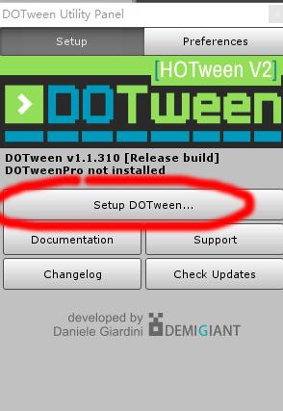
7.If you can not find the menu. Restart the Editor and try again.

Publish to appstore
Before reading this page. You required at least very familiar of how to publishing to appstore. Otherwise please read related tutorials by apple first.
When you compile the xcode project exported by unity. You should make sure the following frameworks were included in your project.
And here is the list, please require these following frameworks manually.
Select targets first,on Build phases-link binary with libraraies
Libsqlite3.tbd
Security.framework
Libz.1.2.5.tbd
Messengui.framework
Mobilecoreservices.framework
Glkit.framework
Adsupport.framework
Mediatoolbox.framework
GoogleMobileAds.framework
Except the last GoogleMobileAds framework.All these can be find directly in xcode. You need to download Admob framework and add this frame into project file first.
You can download here
The other thing is the bitcode. You need to turn it off before your achieve. In build settings , search Enable Bitcode , Set it to NO.

How to get support
Contact to us
E-mail
Remember attach your invoice provement otherwise there would not be my reply.
If you want support our work or feel interested in other assets, take a look at
More Games

